PROJECT REPORT: Stored XSS Attack on DVWA

1. Introduction:
The objective of this assignment was to demonstrate a Stored Cross Site Scripting (XSS) vulnerability in the Damn Vulnerable Web Application (DVWA).

2. Lab Setup:
First, we checked the IP addresses of both our machines - Kali Linux (Attacker Machine) and Metasploitable 2 (Victim Machine) to ensure both are on the same network.

Command used: ip a

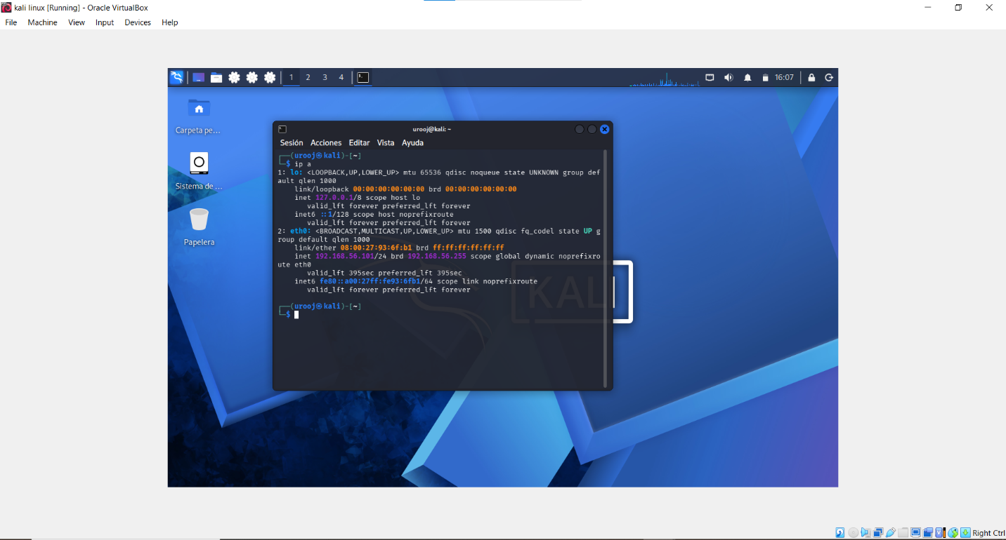
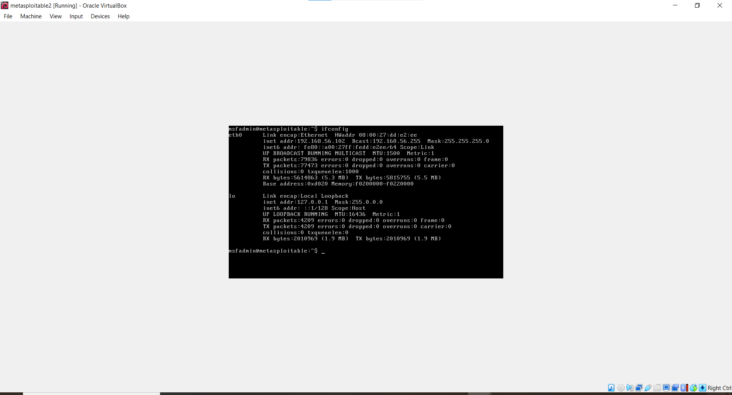

3. Accessing DVWA:
We accessed DVWA by entering the Metasploitable IP in the Kali browser.
URL: 192.168.56.102/dvwa/login.php

Credentials used for login:
Username: admin
Password: password

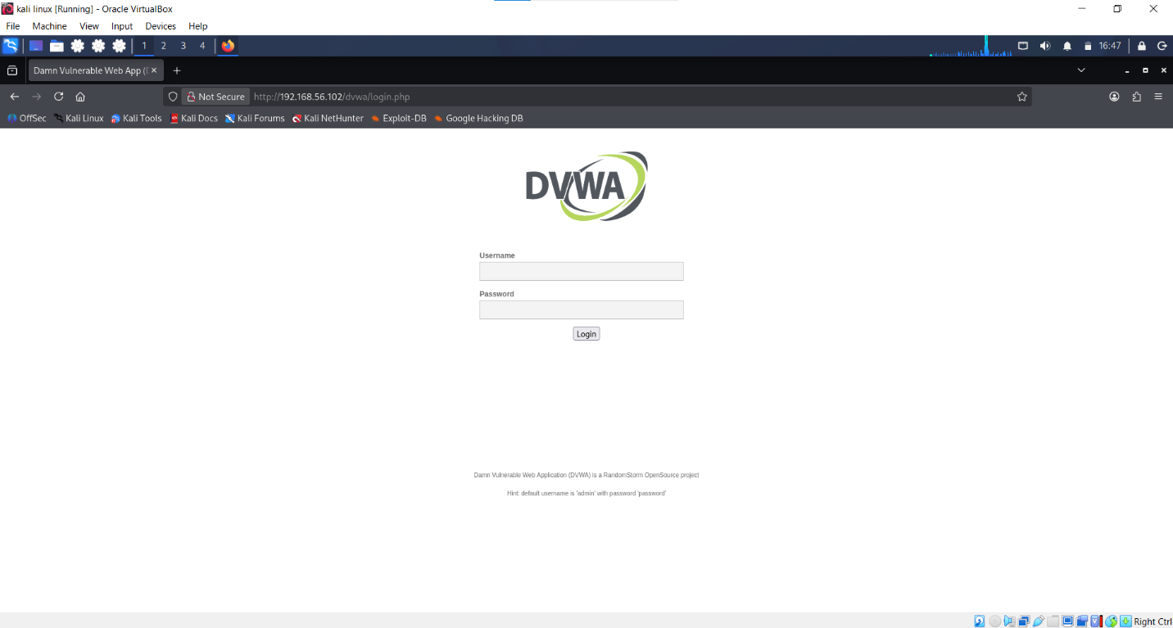

4. Setting Security Level to Low:
To exploit the vulnerability, we needed to set the DVWA security level to low.
We clicked on DVWA Security from the left menu, selected 'low' from the dropdown and clicked Submit.
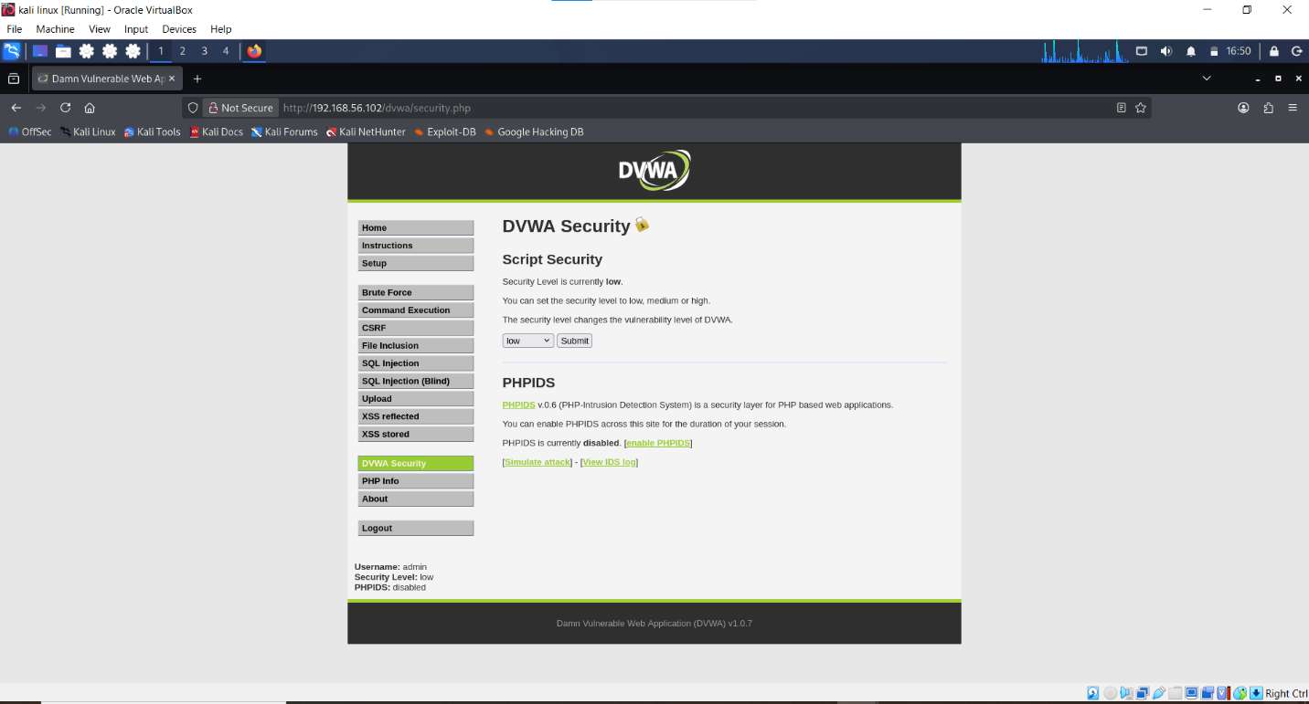

5. Performing Stored XSS Attack:
From the left menu, we clicked on XSS (Stored).
In the Guestbook form, we entered the following payload:

Name: test
Message: <script>alert('XSS Attack Done')</script>

Then we clicked on Sign Guestbook.

6. Proof of Exploit:
As soon as we clicked Sign Guestbook, a JavaScript alert box popped up with the message "XSS Attack Done".

This proves that the website is vulnerable to XSS and an attacker can inject malicious scripts. It is called Stored XSS because the malicious script is stored in the database and executes every time the page is loaded.
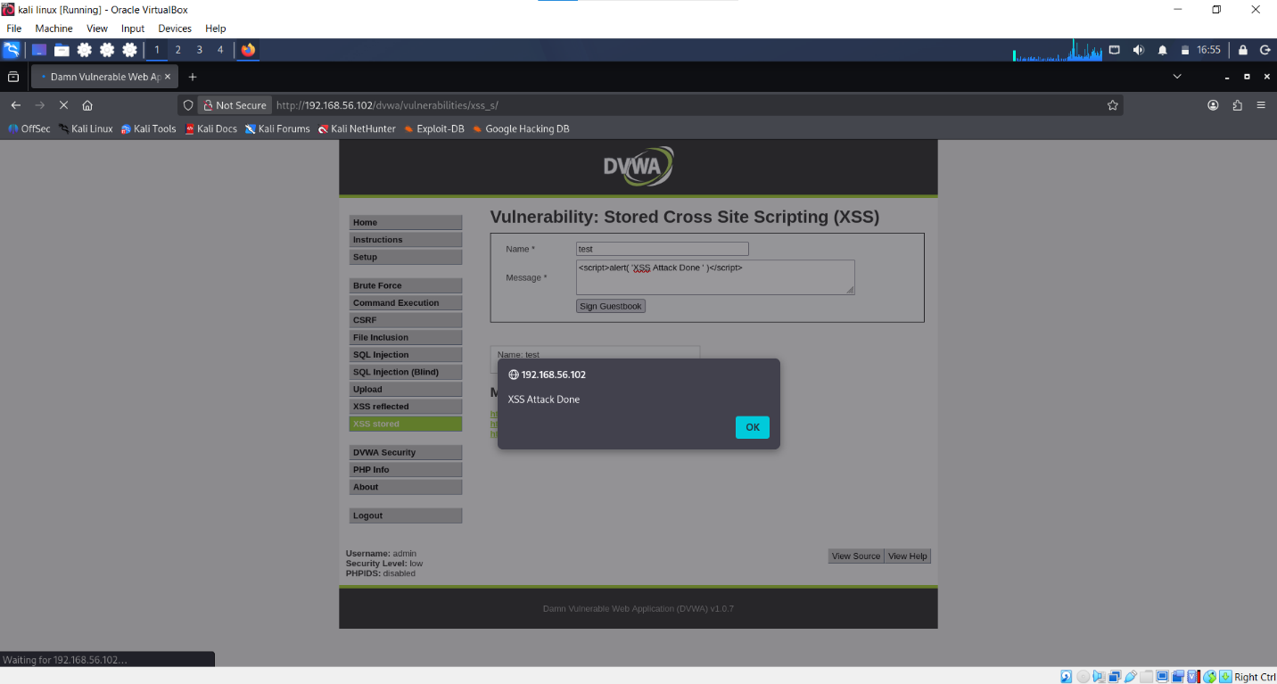

7. Conclusion:
From this project, we learned that if proper input validation is not implemented on a website, a dangerous attack like Stored XSS can occur. To prevent this, developers should use Input Validation and Output Encoding.

